USE CASE – 5
Time Series Forecasting

Team Members:

1 | VTU25834 | PALLERLA RANI SUSMITHA
2 | VTU25844 | YERRAM RUSHIKESH REDDY
3 | VTU25845 | BANDLAPALLI JYOSHNA
4 | VTU25863 | YATHAM ANIL KUMAR REDDY
5 | VTU25879 | PALREDDY SRAVAN KUMAR REDDY
6 | VTU25928 | CHERUVUPALLI NAGA HEMANTH
7 | VTU26001 | KANDAGATLA ROHITH
8 | VTU26063 | PASUPULA SUSHMA
9 | VTU26139 | PONNOLU MANJUNATH REDDY

Time Series Forecasting
Aim :- To design and implement a deep learning model that can analyze historical time-based data and accurately predict future values using sequential patterns.
Algorithm :-
- Data Collection
  - Gather time series data (e.g., stock prices, temperature, sales data).
- Data Preprocessing
  - Handle missing values
  - Convert data into supervised learning format (input-output sequences)
- Build Deep Learning Model
  - Use LSTM layers (suitable for sequential dependencies)
  - Add Dense output layer
- Compile Model
  - Loss function: Mean Squared Error (MSE)
  - Optimizer: Adam
- Train Model
  - Fit model on training data
  - Use epochs and batch size
- Make Predictions
  - Predict on test data
  - Inverse transform to original scale
- Evaluate Model
  - Metrics: RMSE, MAE
  - Compare predicted vs actual values
Program:
import numpy as np
import pandas as pd
import matplotlib.pyplot as plt
from sklearn.preprocessing import MinMaxScaler
from tensorflow.keras.models import Sequential
from tensorflow.keras.layers import Dense, LSTM
data = pd.read_csv('airline_passengers.csv')
dataset = data['Passengers'].values.reshape(-1,1)
scaler = MinMaxScaler(feature_range=(0,1))
dataset_scaled = scaler.fit_transform(dataset)
def create_dataset(data, time_step=60):
X, y = [], []
for i in range(len(data)-time_step-1):
X.append(data[i:(i+time_step), 0])
y.append(data[i + time_step, 0])
return np.array(X), np.array(y)
time_step = 60
X, y = create_dataset(dataset_scaled, time_step)
train_size = int(len(X) * 0.8)
X_train, X_test = X[:train_size], X[train_size:]
y_train, y_test = y[:train_size], y[train_size:]
X_train = X_train.reshape(X_train.shape[0], X_train.shape[1], 1)
X_test = X_test.reshape(X_test.shape[0], X_test.shape[1], 1)
model = Sequential()
model.add(LSTM(50, return_sequences=True, input_shape=(time_step,1)))
model.add(LSTM(50))
model.add(Dense(1))
model.compile(optimizer='adam', loss='mean_squared_error')
model.fit(X_train, y_train, epochs=20, batch_size=32)
train_predict = model.predict(X_train)
test_predict = model.predict(X_test)
train_predict = scaler.inverse_transform(train_predict)
test_predict = scaler.inverse_transform(test_predict)
plt.plot(dataset, label='Actual Data')
plt.plot(range(time_step, time_step+len(train_predict)), train_predict, label='Train Prediction')
plt.plot(range(time_step+len(train_predict), time_step+len(train_predict)+len(test_predict)), test_predict, label='Test Prediction')
plt.legend()
plt.show()

Output :
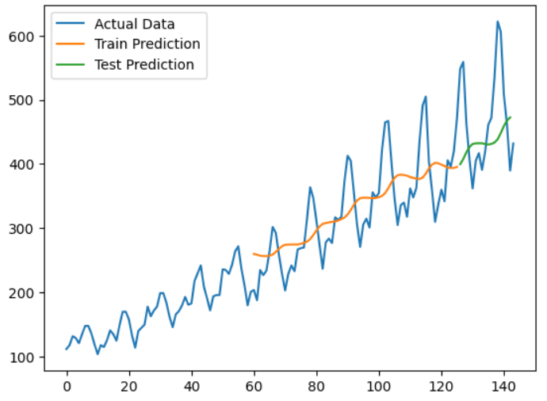

Result :
The LSTM model was successfully trained on the time series data and was able to predict future values. The predicted results closely match the actual data, showing that the model performs well for forecasting.

